**Project 30**

**Stack Questions:**

**Q3. Challenge:** Show stack trace for ["X", "Y", "Z", "W"] with 2 pops

For stack follow LIFO, this means the last item pushed in the stack ("W") will be the first popped out.

**Algorithm Design:**

**Step 1: Initialize an empty stack**

**Step 2: Push items onto the stack in the given order: X ➜ Y ➜ Z ➜ W**

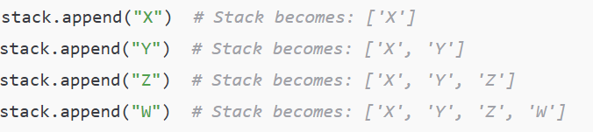

**Step 3: Show Initial Stack**

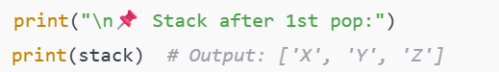

**Step 4: Perform First Pop Operation**



**Step 5: Perform Second Pop Operation**



**Final Output**

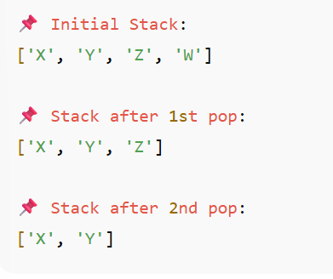

**Reflection**: Why stack supports temporary storage of steps?

* A stack works on the **Last In, First Out (LIFO)** principle, meaning the most recent step is accessed first.
* This makes it ideal for situations where **recent actions need to be reversed or revisited** before earlier ones.
* It helps **temporarily store steps** in a way that preserves their order but allows accessing them in reverse when needed.
* Stacks are especially useful for **backtracking**, such as undoing actions, managing function calls, or navigating nested tasks.
* Since only the top item is accessible, stacks **simplify management of temporary data** by focusing on the most recent context.
* This ensures **controlled, reliable, and step-by-step processing** of actions, making stacks essential for both computing and logical workflows.